**Batch Code: 1907F1 E-PROJECT**

|  |  |
| --- | --- |
| DREAMWEAVER-E-PROJECT    GIFTSONLINE.COM | |
| Group Members**Dania Shabih (Student)****Masooma (Student)****Saad Javeed (Student)** | |
|  | Submitted To**eprojects@aptech.ac.in**Project Instructor[**Miss**](mailto:eprojects@aptech.ac.in) **Rabiya Amin**Curriculum Code**6740** C:\Documents and Settings\Afnan Yousuf\Desktop\Aptech-new-logo.jpg  NAV BAR |
|  | |

HOME PAGE

## **CLICK ON "HOME" PAGE & HOME PAGE WILL BE APPEAR**



CONTACT US

## **CLICK ON "CONTACT US" & CONTACT US PAGE WILL BE APPEAR**

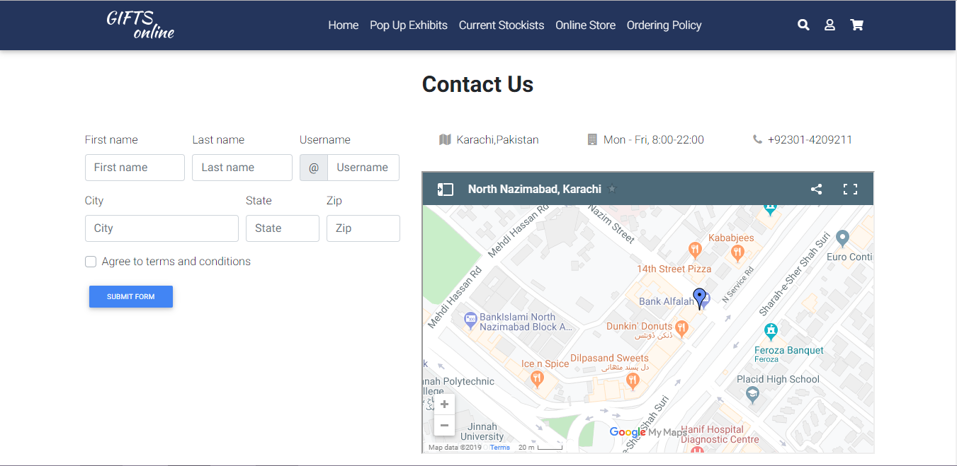

ABOUT US

## **CLICK ON "ABOUT US" & ABOUT US PAGE WILL BE APPEAR**



SIGN UP

## **CLICK ON "SIGN UP" & SIGN UP PAGE WILL BE APPEAR**



FOOTER

